AIRG Simulated 1000 Paths

* Before the simulation, I first updated the historical curve of 3m UST, 5Y UST, 20YR UST using SBBI and FRED data

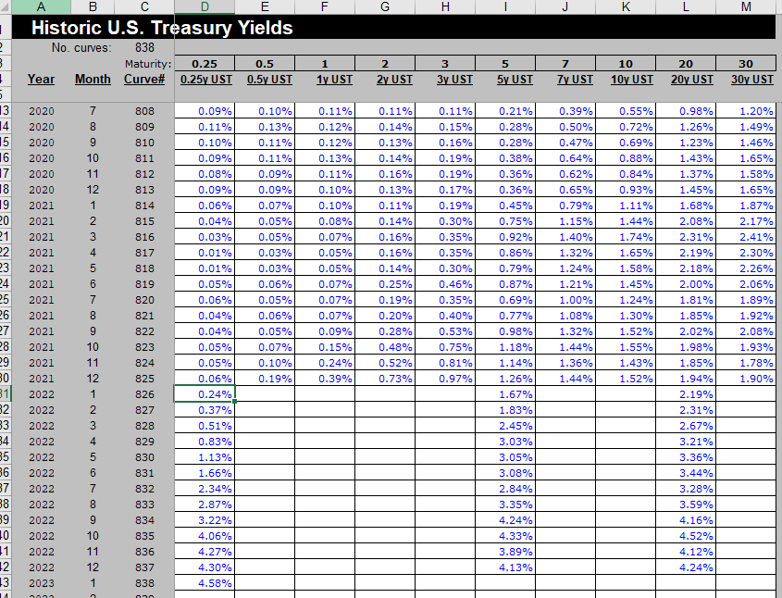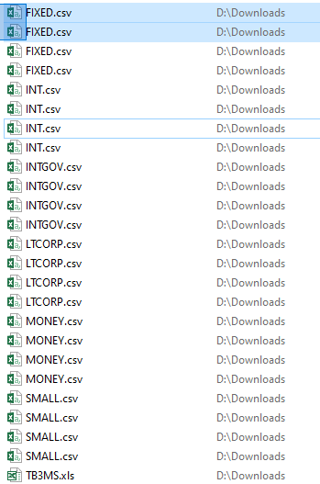some unknown results

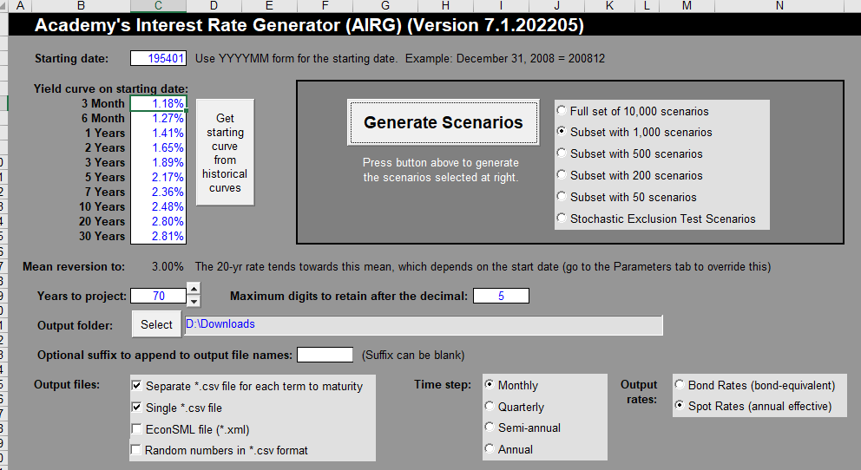

* Using starting date as 1954.01
* SBBI data is from 1926.01 to 2022.12
* Simulate for 70 years of data
  + So the simulated range is from 1954.01 – 2024.01
    - * Simulated categories we will use
      * UST_3M
      * UST_20Yr
  + Historical subset is from 1954.01 – 2022.12
    - Long term Corp TR (20 YR) is missing data from 2022.04 – 2022.12

NAIC MODEL DATA

* 873 paths test 1a (2021.12.31)
* Each time span is 1200 (if monthly data, have 100 years of data)
* 
 